**SQL QUERIES**

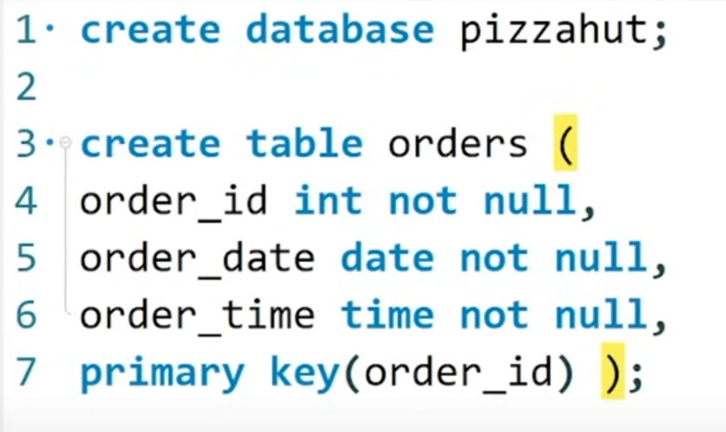

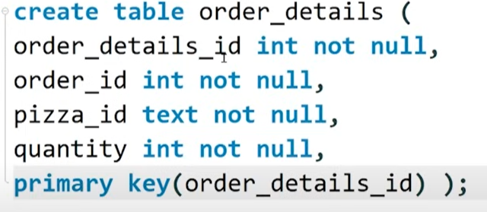

**Q/ANS**

**Retrieve the total number of orders placed.**

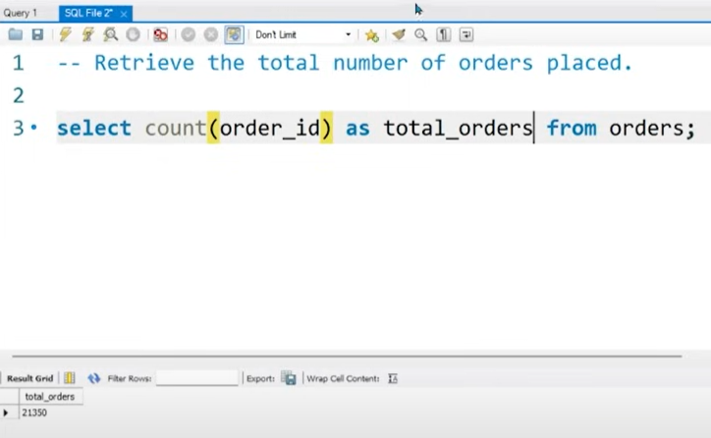

**Calculate the total revenue generated from pizza sales.**

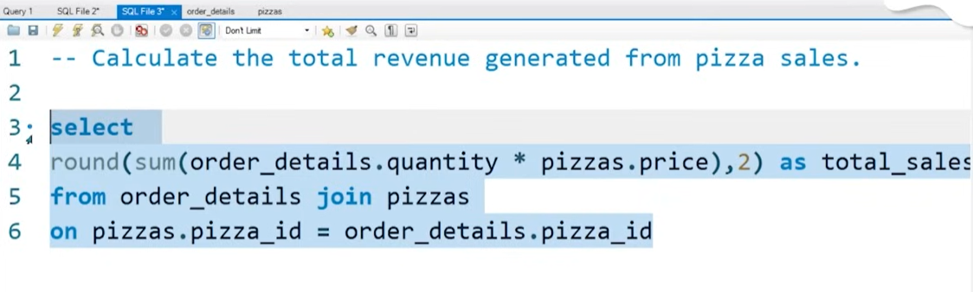

**Identify the highest-priced pizza.**

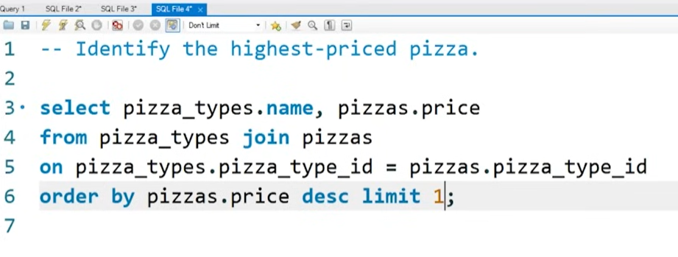

**Identify the most common pizza size ordered.**



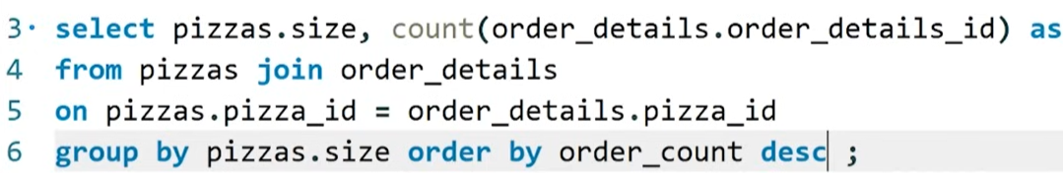

**List the top 5 most ordered pizza types along with their quantities.**

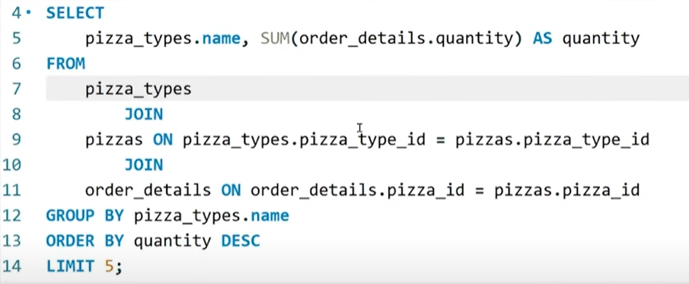

* **Join the necessary tables to find the total quantity of each pizza category ordered.**

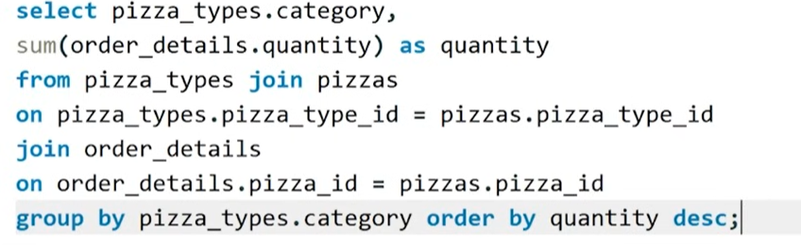

* **Determine the distribution of orders by hour of the day.**

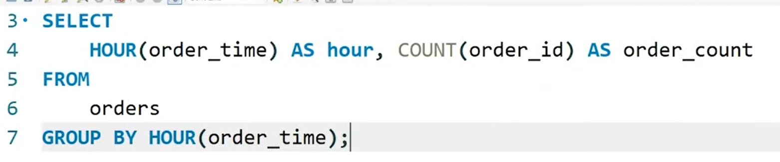

* **Join relevant tables to find the category-wise distribution of pizzas.**

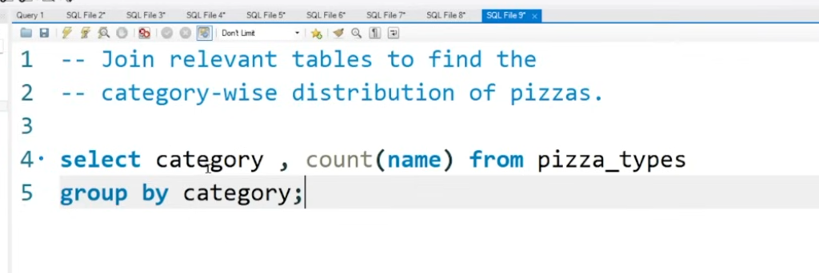

* **Group the orders by date and calculate the average number of pizzas ordered per day.**

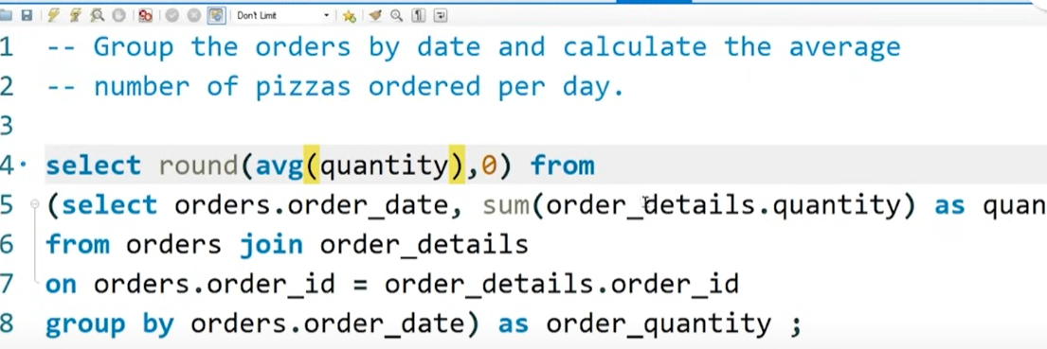

* **Determine the top 3 most ordered pizza types based on revenue.**

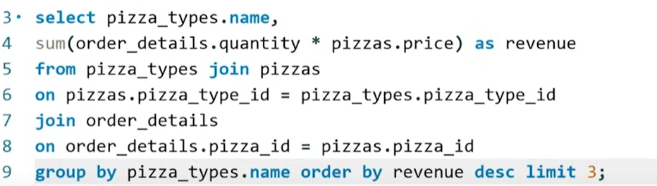

* **Calculate the percentage contribution of each pizza type to total revenue.**

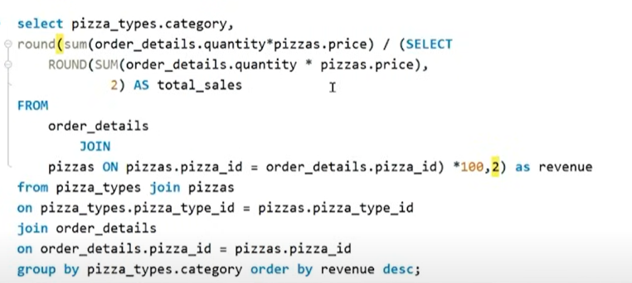

* **Analyze the cumulative revenue generated over time.** 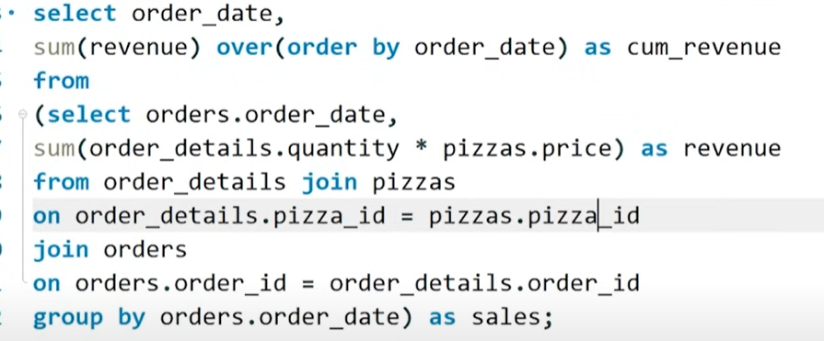
* **Determine the top 3 most ordered pizza types based on revenue for each pizza category.**

